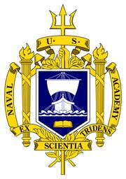 | 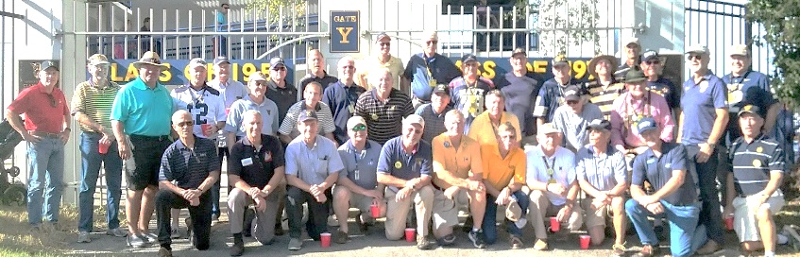 | 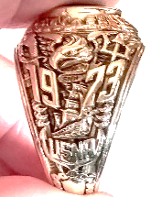
Class Links | Welcome to new USNA Class of 1973 Website | Quick Links
From President | Center Section – reunion, news flash | USNA website
Class Officers -> | Names and Contact Information, Pictures | Visit the USNA
Class Projects -> | Current and Past, Pictures | Navy Sports
Company Reps -> | Names and Contact Information, links to company webpages | Alumni Assn.
45th Reunion -> | Dates, Schedule, Registration, Company Get-Togethers ….. | Class Directory Sign-In
Regional Events and Reps -> | Annapolis, Norfolk, Southeast, San Diego, Hawaii, | Shipmate Magazine
Shipmate Articles -> | By monthly editions (Leif may do) | E- WaveTops
73 Tailgates -> | Sponsors, Themes, Photos…. | Navy Online Store
Last Call -> | Classmates who have gone before us. Obituaries-special memories? | Class Crest Items
Photo Galleries -> | Events, Classmates, Navy/USMC family members …. | Visit Annapolis
Lucky Bag Memory Lane -> | 1969-73 photo memories, Then and Now ….. | USNA Performing Arts
Notable Classmates -> | Astronauts, Authors, Celebrities, Congress/Senate, Senior Military Ranks, Professional Sports, Olympians, etc.
Around the Yard -> | Then and Now – pictures of the Academy
Reef Points/Gouge -> | Navy/USMC Songs, 1969-74 Trivia Questions, Challenges, Navy History, Navy Terms, Reef Points Quizzes, Xwords, etc.
Other? | Other? | Other?

