Guidance For Distinguished Graduate Award Submissions

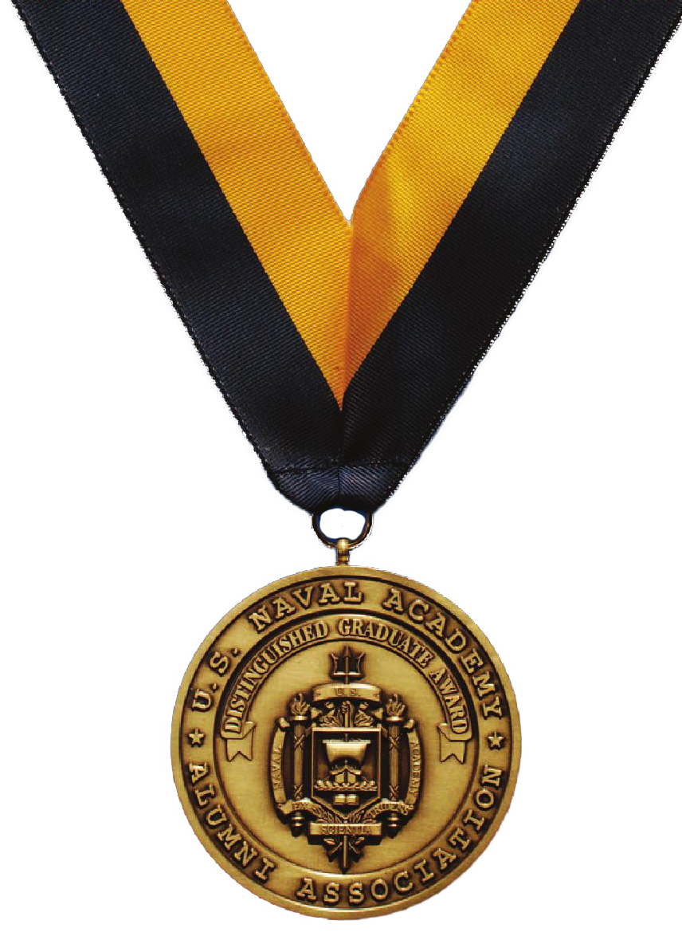
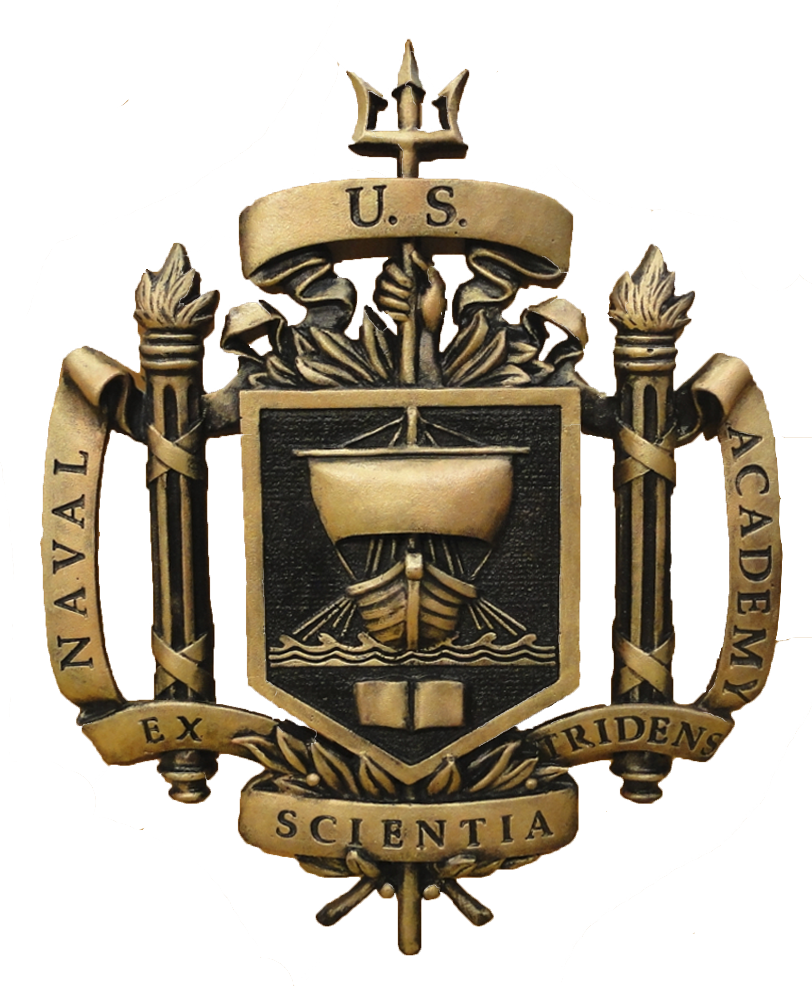
The President of the Class of 1973 has established a Distinguished Graduate Award (DGA) Committee responsible for receiving, reviewing / editing and nominating qualified and deserving classmates to the United States Naval Academy Alumni Association (USNAAA) DGA Selection Committee. No more than two new nominees will be submitted in any given year. All members of the 1973 DGA Committee are selected (with term limits) by the Class President; term limit(s) may be renewed / extended at the discretion of the Class President.

Those wanting to nominate a member of the Class of 1973, should first notify the Chairman, Class of 1973 DGA Committee, NLT 01 April of the nomination year, of their intent to submit a nomination package. The purpose of this notification is to eliminate duplicity in effort if someone else is already preparing a package for the class member.

All nominations for the Class of 1973 shall be submitted to the Chairman, Class of 1973 DGA Committee as a submission worthy package; complete, formatted and compliant with the following,

- USNAAA Distinguished Graduate Award Nomination Packet Guidelines. These guidelines can be found at https://www.usna.com/DGA?
- Class of 1973 Package Guidelines (contained in this document)

USNAAA Guidance shall always take precedence in the event of conflict.

The aforementioned (complete) nomination packages shall be submitted digitally in Microsoft Word to the Chairman, Class of 1973 DGA Committee NLT 01 July. The miscellaneous pages (11-13) may be submitted as .pdf or .jpg files but must contain the proper pages and footers. It will be the responsibility of the Class of 1973 DGA Committee to print and acquire all signatures prior to submission to the USNAAA DGA Selection Committee. All submissions will be done via certified mail.

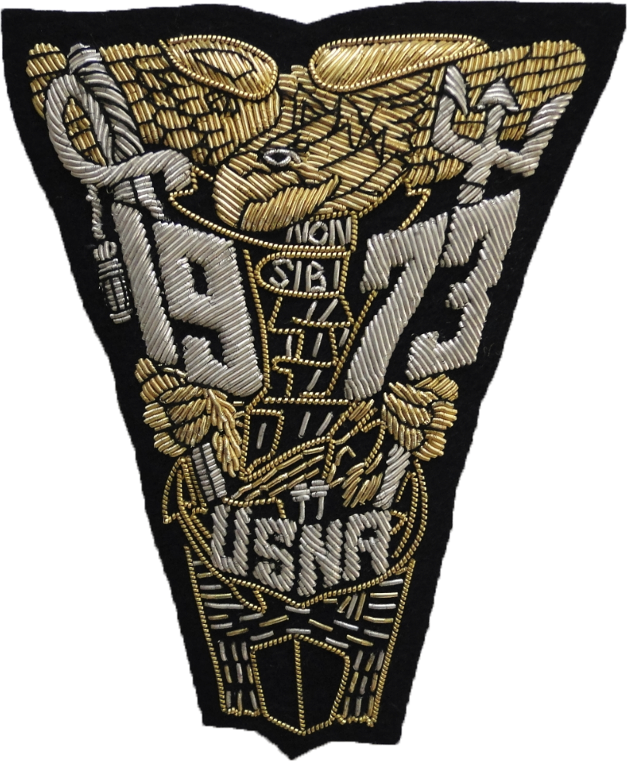
Class of 1973 Package Guidelines

Each package shall consist of 14 total pages
(13 Pages + Cover)

Cover Page (Not Numbered). The President of the Class shall sign all Class of 1973 nominees.

The following pages shall be numbered in sequence 1 through 13 in accordance with the enclosed guidance.

Page 1 (Nomination Letter). This page should have a macro overview of the nominee. All nomination letters will be signed by all three (3) Class of 1973 DGA Committee members.

Page 2 (Executive Summary). This page will be submitted in the following (bullet) format.

USNA and Military Highlights, Awards and Medals
- Highlight | Highlight | Highlight | Highlight
- Award or Medal | Award or Medal | Award or Medal

Government / Civilian / Business / Community Highlights, Awards, Certificates
- Highlight | Highlight | Highlight | Highlight
- Award or Certificate | Award or Certificate | Award or Certificate

Summary of Support of / Service to USNA and Brigade of Midshipman
- Support or Service | Support or Service | Support or Service

Summary of Support for the Alumni Association and / or Foundation (gifts of “time, talent, and / or treasure”)
- Time or Talent or Treasure | Time or Talent or Treasure

Other Notable Achievements
- Achievement | Achievement | Achievement
Pages 3 - 5 (Endorsements of Nominee). Within the 3-page limitation, packages shall have a minimum of two (2) endorsements. These endorsements shall be scanned and imported into the word document to facilitate pagination of the nomination package. Each endorsement shall contain a “Certified True Copy and the name of the preparer” in the lower left corner of the last page of the endorsement in size 9 font. The preparer of the package shall sign his name over the certified true copy statement. Preparers shall maintain the original endorsements until notified by the Chairman, Class of 1973 DGA Committee that they are no longer required.

Pages 6 - 10 (Narrative). The structure of the nomination package narrative is up to the preparer of the package within the guidance of the USNAAA Distinguished Graduate Award Nomination Packet Guidelines. The structure of the narrative should be done in such a way to best represent the nominee. The structure of the narrative should create a natural flow for the reader.

Pages 11 – 13 (Miscellaneous). The selection of this information is up to the preparer of the package within the guidance of the USNAAA Distinguished Graduate Award Nomination Packet Guidelines. Ensure all pages are numbered correctly / appropriately.

Questions regarding the submission package should be made to the Class of 1973 DGA Committee Chairman.

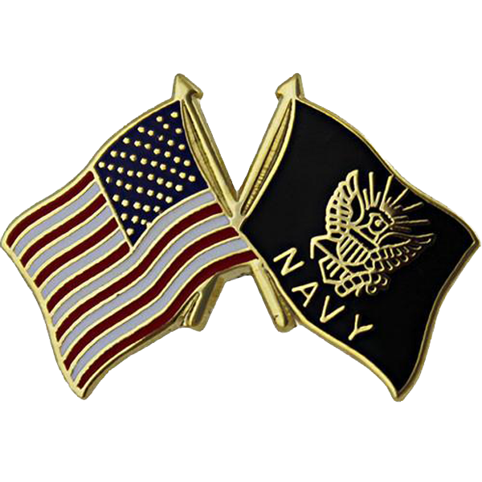
Current DGA Committee Members
(Dates Next To Members Indicates Their Terms Of Membership)

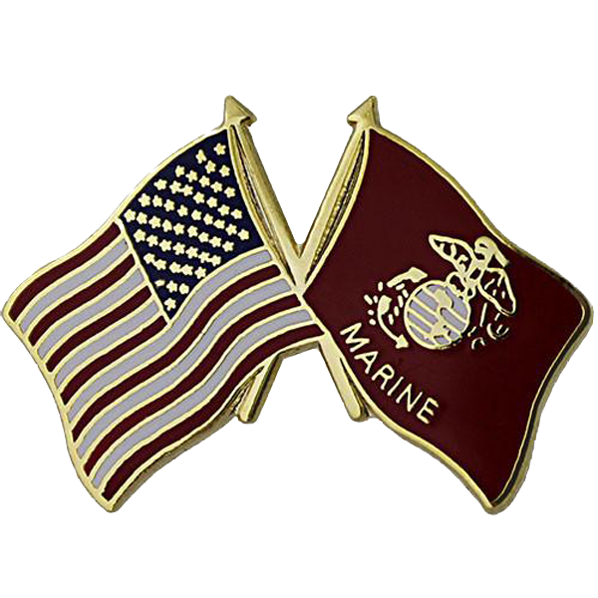
Tom Storch, Chairman (2016 – 2018); Tomawacs@aol.com

Leif Hendrickson, Member (2016 – 2018); Leif1775@gmail.com

Paul Ryan, Member (2016 – 2018); Pauljryan@aol.com

