Class of 1973 LAST CALL – Names, dates, home of record, specialty, etc.
Add: Karen will copy and add LB picture, (need help here) sports/activities, Navy/USMC assignments, other?
Please edit (in red) and write-up links to more extensive obituaries that include family, etc.
Richard Jackson Allen
20 May 1973
Joseph Donald Anderton
-- 9 September 1969
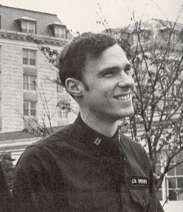 | James Bradley “JB” Brown, Jr., LT, USN  18th Company, B.S. Applied Science, Surface Line (LB Pg. 394)  25 Apr 1951 – 28 Nov 1979, Age 28, from Wickford, RI  NL 626, squadron CO, killed in an EA-6B Prowler plane crash off the Kitty Hawk, near Diego Garcia, British Indian Ocean Territory.  Class of 1973 in USNA Memorial Hall
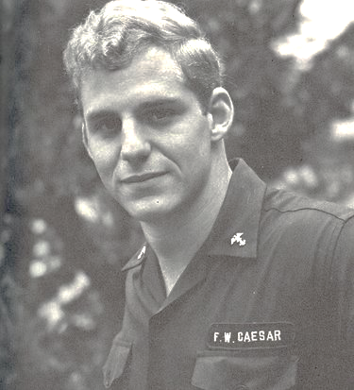 | Frederick William Caesar, III, LTJG, USN  29th Company, B.S. Mathematics, Navy Air (LB Pg. 473)  10 May 1951 – 20 Jan 1977, Age 25  Sikorsky HH-52A Seaguard, 1448 was performing an aerial ice patrol along the Illinois and Mississippi rivers. The aircraft struck three electrical transmission wires and crashed into the ice-filled river. The aircraft and/or crew were assigned to Air Station Chicago, Illinois.  Class of 1973 in USNA Memorial Hall
Reginald Richard Campbell
- 6 June 1972
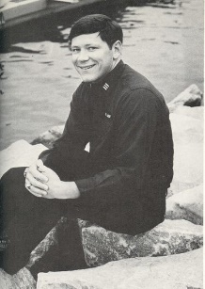 | Brian Lee Cardiff, LTJG, USN  1st Company, B.S. Analytical Management, Navy Air (LB Pg. 265)  Born 2 Jan 1950 in Columbus, Ohio – 25 June 1975, Age 25  Aircraft collision during flight operations off the USS Forrestal near Palma de Mallorca in the western Mediterranean. Shortly before nightfall, the “BUCKEYE 511’, and A-6E Intruder with Lt(JG) Cardiff and crew, collided in mid-air with Aircraft No. 611, a Grumman EA-6B Prowler.  Class of 1973 in USNA Memorial Hall
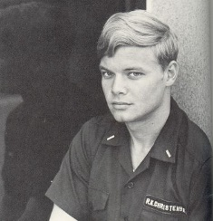 | Robert K. Christensen, CDR, USN  31st Company, B.S. Mathematics, Navy Air (LB Pg. 486)  19 Aug 1951 – 24 July 1992  CO of Strike Squadron (VFA) 37 when the F/A-18 he was piloting crashed off the coast of Vieques on the night of 24 July 1992.  Class of 1973 in USNA Memorial Hall
Steven Owen Coats
- 20 May 1973
John L. “Dails” Dailey, Jr. CAPT, USN (Ret)
15th Company, B.S. Foreign Affairs, Surface Line (LB Pg. 374)
March 20, 2012, age 61, born and raised in Aurora Ill
1989 – earned a Masters in International Public Policy from Johns Hopkins University in Baltimore.
During his 29 years, John served aboard ship, in the Pentagon, the Naval War College, and most notably as a helicopter pilot. In 1991 he assumed command of Helicopter Squadron H-2 based at NAS Norfolk. As OIC of the Detachment, John led the squadron in theater during the Gulf War.
Lance Fremd, Midshipman 1st Class, (going) USMC
15 July 1951 – 6 Aug 1972, Age 21
Died in a skydiving accident in Ridgely, MD.
See Pittsburg news article.
Class of 1973 in USNA Memorial Hall
Michael Jay Gage
25th Company, B.S. Aerospace Engineering, Nuclear Power (LB Pg. 446)
- 21 July 2014
B.S. aerospace engineering, with graduate degrees in engineering and math education. Served on the nuclear submarines Tecumseh and Birmingham.
John Collins Harvey
5th Company, Political Science Major, going Nuclear Power (LB Pg. 298)
d. 6 June 1972
Scott Lars Hendrickson, CAPT, USN (Ret)
9th Company, B.S. Operations Analysis, Navy Air (LB Pg. 331)
d. 30 Dec 2003, Age 52, at NNMC Bethesda MD
Helicopter Pilot, CO of HSL – 34 at Naval Air Station Norfolk, VA.
Persian Gulf War Veteran, served as Air Boss of the USS Iwo Jima, then
Chief of Staff at DISA Westhem. Captain Hendrickson also received the Defense Superior Service medal/Meritorious Service medal and 2 Navy Commendation Medals. After he retired from the Navy in 1996, he became a Project Manager with EDS in Herndon, Virginia.
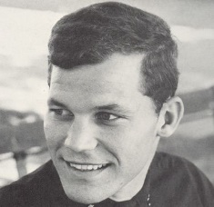 | Derek Ervin Holmquist, LCDR, USN  10th Company, B.S. Electrical Engineering, Navy Air (LB Pg. 337)  15 Mar 1951 – 1 Apr 1985, Age 34  A-6 Intruder jet disappeared in the jungle or mountains of Panama  Attack Squadron 35, based at Oceana Naval Air Station  Class of 1973 in Memorial Hall
James Pennock. “Jim” Hopkins, IV
12th Company, B.S. Spanish, Navy Air (LB Pg. 351)
Born 23 Oct 1951 at Camp LeJeune, NC, grew up in Alexandria, VA
He died suddenly on 28 Nov 2006, age 55
Ran track in high school and at the USNA.
Naval service in anti-submarine warfare with VP-4 and VP-17. His twenty year Navy career took him and his family to Hawaii, Guam, Venezuela, Okinawa, and Virginia.
Frank George Kale, Jr.
(Left early)
1951 - 9 May 2016, age 65
Died following a two-year battle with cancer. Of Duxbury, MA (?)
B.S. in Business, Boston University.
Barry Lee Kelly, CDR
13th Company, B.S. Oceanography, Surface Line (LB Pg. 360)
- 20 Aug 2016
Aviator, Binghamton, TX
George Kerlek, Jr. Maj, USMC
18th Company, B.S. Oceanography, USMC Huey helicopter pilot (LB Pg. 397)
16 Sept 1950 – 8 July 2017, age 66
Pitcher for the US Navy Baseball team and a team captain during his senior year. During the Beirut, Lebanon conflict, he served as the pilot for American diplomat Philip Habib, who mediated between Lebanon and Israel. He later served as a helicopter flight instructor in Pensacola, Florida and New River, North Carolina and worked as a personnel and logistics coordinator at the Pentagon in Washington, D.C. and the Marine Corps Base Quantico in Virginia. He is being interned at USNA Cemetery and Columbarium In Annapolis, MD.
Gary Woodrow Miller,
36th Company, B.S. Foreign Affairs, Navy Air (LB Pg. 527)
4 Jan 1951 – 26 Oct 2016
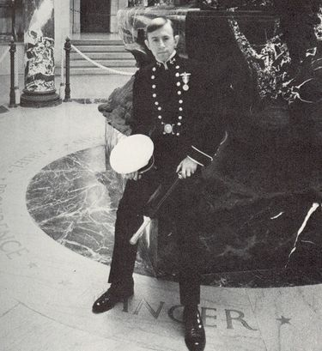 | Frederick Richard Minier, ENS, USN  15th Company, B.S. Spanish, Surface Line (LB Pg. 377)  29 Aug 1951 – 30 May 1975, Age 23  23rd Company Tiger, Fred designed the crest for the Class of 1973  Assistant Damage Control Officer on the USS Sampson DDG-10, home ported in Athens, Greece. Hull inspection area of the main condenser intake, Fred saved the life of the inspection dive team Engineering Officer when he was sucked against the intake grate. Ensign Minier unhesitatingly swam to his assistance and freed the stricken diver, but was himself sucked up and lodged in the main condenser with simultaneous loss of breathing apparatus. For this act of heroism, Ensign Minier was awarded the Navy and Marine Corps Medal for heroism, posthumously.  Class of 1973 in the USNA Memorial Hall
Robert Michael Norman, CAPT, USN (Ret)
29th Company, B.S. Aerospace Engineering, Navy Air (LB Pg. 476)
14 Apr 1952 Jacksonville, FL – 7 Aug 2013
Fighter Pilot, NASA Group 9 Astronaut Group
Lewis Gregory “Greg” Pallas,
27 June 1952 – 17 Oct 2003, Age 51
Graduate of the New York Military Academy and United States Naval Academy, Class of 1973, and served as a United States Naval Officer aboard the USS KITTY HAWK, US Pacific Fleet, and at the Pentagon. Following his military service, Greg was employed for 18 years in the United States Senate as Legislative Director and Chief of Staff to Senator J. James Exon of Nebraska. Upon Senator Exon's retirement in 1996, Greg was employed as Director, Congressional Liaison and Business Development at ITT Industries, Defense, McLean, VA.
Charles Ralph Porcelli, LCDR, USN
23rd Company, B.S. Analytical Management, Navy Air (LB Pg. 437)
- 15 May 2015, Age 63.
Passed away unexpectedly at his residence in Telford, PA.
Navy Pilot. Years of service 1973 – 1986. Born in Jamaica, NY. Worked as a systems engineer for NAVMAR Applied Sciences in Warminster.
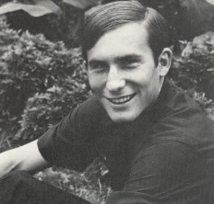 | James Carlton Radney, LCDR, USN  12th Company, B.S. Oceanography, Nuclear Power (LB Pg. 353)  - 28 Sept 1982, Age 31  Key West Naval Air Station, Fort Meyers, Florida. Navy Pilot, SH-2F Seasprite anti-submarine helicopter crash.  Class of 1973 in USNA Memorial Hall
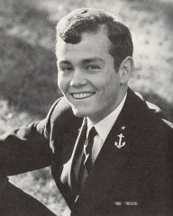 | Craig Otis Reynolds, LT, USN  7th Company, B.S. Analytical Management, Navy Air (LB Pg. 314)  18 Oct 1951 – 22 Mar 1978, Age 26  Pilot U-341 (?)  Buried at Fort Rosecrans National Cemetery, San Diego  Class of 1973 in USNA Memorial Hall
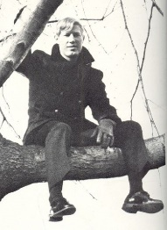 | Randy Jow Rickey, LT, USN  34th Company, B.S. Analytical Management, Navy Air (LB Pg. 512)  - 16 Oct 1977, Age 26, from Pinellas Park, Florida  After participating in a 7th Fleet amphibious exercise in the Philippines, Randy’s A4 Skyhawk jet fighter crashed when preparing to land, Lt. Randy J. Rickey ejected but was killed when his plane crashed into Subic Bay.  Class of 1973 in USNA Memorial Hall
Larry Edward Rutledge,
34th Company, B.S. Analytic Management, Supply Corps (LB Pg. 511)
- 6 Aug 2014
Thomas E. “Tom” Silva
19th Company, B.S. Mechanical Engineering, Nuclear Power (LB Pg. 406)
Died unexpectedly on 17 April 2013, Age 61
Thomas Joseph Somok
27 June 1970
Terence S. “Terry” Wilson,
9th Company, Systems Engineering, Navy Air (LB Pg. 333)

William Stephen Weise
3rd Company, B.S. Analytical Management, Navy Air (LB Pg. 287)
- 14 Dec 2014
Connecticut
Donald Hobart White
17th Company, B.S. Management, Surface Line (LB Pg. 373)
- 7 Mar 2014

