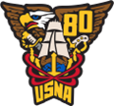
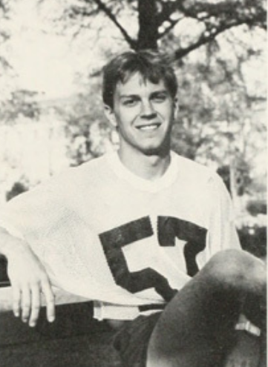
Gerard Gary “Smitty” Smith


On May 9th 35 Classmates were among the many other family and friends that attended the funeral Mass for Gary "Smitty" Smith who passed away on March 30, 2022. It was a celebration of Smitty's life as a cherished Classmate, friend, father, coworker, and former youth basketball coach. Following Mass a Navy Honor Guard played Taps and presented Smitty's oldest daughter, Amanda, with a flag that had been flown over the Naval Academy on May 1, 2022, on what would have been Smitty's birthday. Carl Hendershot, Smitty's roommate at NAPS and godfather to Amanda, gave a moving tribute to Smitty's fierce loyalty and devotion to his friends and those he loved, particularly those from his time at the Academy. Carl led the alumni in singing Navy Blue and Gold in Smitty's honor.

